Nav

Button

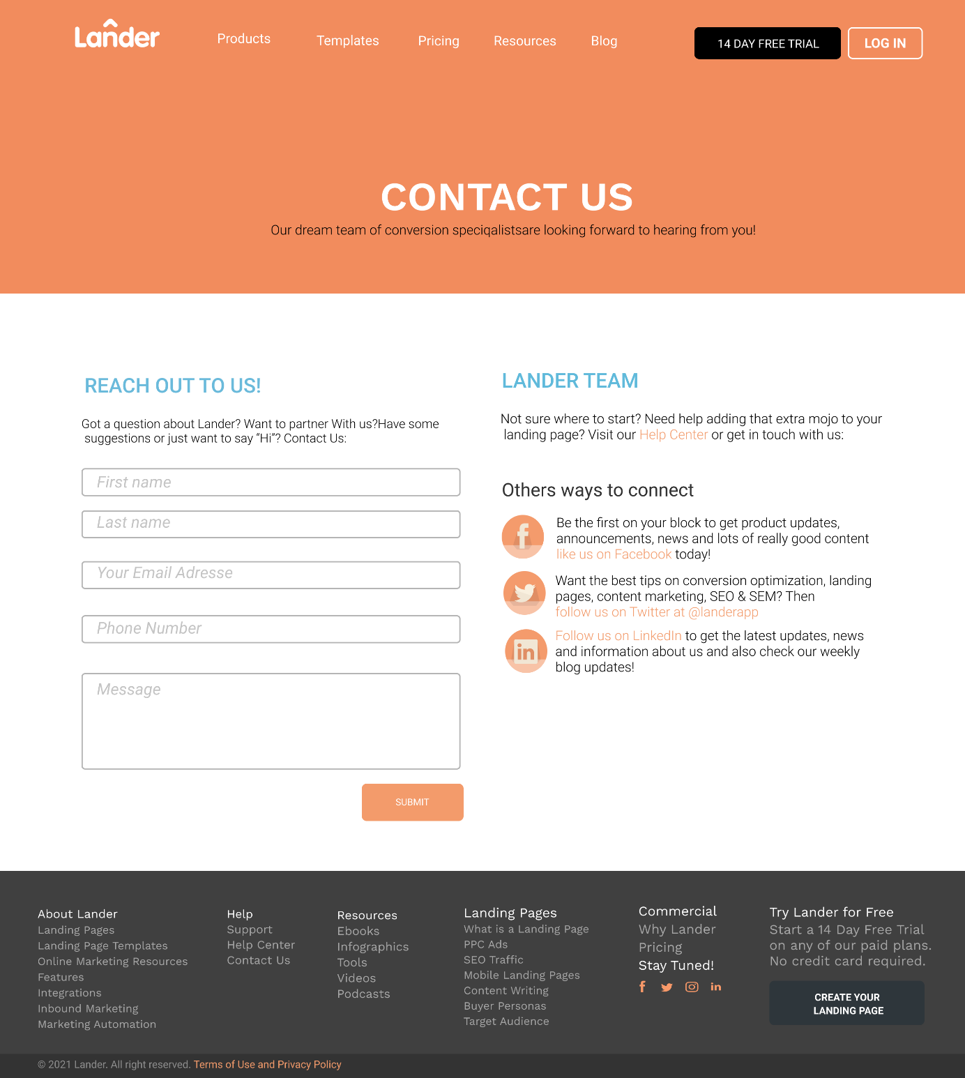

Header

Button

Footer

input

Main